Additional File 2

Table S1: Gene name and gene ID of DCLs from Arabidopsis, Medicago, rice, Populus, Physcomitrella and grapevine.

Gene name* | Gene ID | Gene name* | Gene ID
AtDCL1 | At1g01040 | PtDCL1 | Potri.002G181400.1
AtDCL2 | At3g03300 | PtDCL2a | Potri.010G181400.1
AtDCL3 | At3g43920 | PtDCL2b | Potri.008G075900.1
AtDCL4 | At5g20320 | PtDCL3 | Potri.018G047500.1
MtDCL1 | Medtr7g118350 | PtDCL4 | Potri.006G188800.1
MtDCL2 | Medtr2g030490 | PpDCL1a | LOC112278919
MtDCL3 | Medtr3g105390 | PpDCL1b | LOC112284512
OsDCL1 | Os03g02970 | PpDCL3 | LOC112275623
OsDCL2a | Os03g38740 | PpDCL4 | LOC112277957
OsDCL2b | Os09g14610 | VvDCL1 | VIT_00027460001
OsDCL3a | Os01g68120 | VvDCL2 | VIT_00019052001
OsDCL3b | Os10g34430 | VvDCL3 | VIT_00035494001
OsDCL4 | Os04g43050 | VvDCL4 | VIT_00001045001
*At, Mt, Os, Pt, Pp and Vv indicated A. thaliana, M. truncatula, O. sativa, P. trichocarpa, P. patens and V. vinífera respectively.

Table S2: List of primers and amplicon characteristics of DCL genes
Gene | Forward | Reverse | Amplicon size (bp) | Efficiency ± SD* | R2
DCL1 | TTCCGAGGAAAGAGGGCTAT | TTGCAGCTCAACTCAACACC | 105 | 0.928647 ±  0.0283724 | 0.9859
DCL2a | ACTTCCGGGGTTTATCCGTG | TTTGCATTACACAGTGTTTCCTCA | 108 | 0.98622 ±  0.00353329 | 0.9466
DCL2b | GCTGTCTTCTTGGTTCCCCA | AGTCAACCTCCATATCTCCCCA | 102 | 0.997162 ±  0.0091986 | 0.9908
DCL3a | TCTGCTGTTAGCCTCATCCA | GAACGGCTGCATTAACAGGT | 139 | 0.992603 ±  0.0061324 | 0.9875
DCL3b | CGCTTCTTCAAGGACAGCAT | GGCCATAACTGTTTCCGACA | 99 | 0.964982 ± 0.0028187 | 0.9754
DCL4 | TTATTCAAGCTGGCAACAAGG | CAAATTACTGGGCAGGGATG | 104 | 0.976748 ±  0.0088974 | 0.9989
*Efficiency ± standard deviation (SD) generated by the Miners software.
References genes (miR390 and PP2A) were used according Fausto et al., 2017.

Table S3 - DCL expression in organs

Sample/ gene | DCL1 | DCL2a | DCL2b | DCL3a | DCL3b | DCL4
FM_Leaf ± SD | 0.198 ± 0.058 | 1.538 ± 0.033 | 3.010 ± 0.140 | 1.883 ± 0.082 | 0.0335 ± 0.007 | 1.803 ± 0.101
DO_Leaf ± SD | 1.031 ± 0.150 | 1.428 ± 0.124 | 0.007 ± 0.007 | 1.466 ± 0.475 | 0.002 ± 0.006 | 1.054 ± 0.571
FM_Flower ± SD | 2.252 ± 0.013 | 1.005 ± 0.034 | 0.073 ± 0.003 | 1.629 ± 0.087 | 1.321 ± 0.066 | 0.190 ± 0.054
DO_Flower ± SD | 1.261 ± 0.063 | 0.353 ± 0.086 | 0.974 ± 0.067 | 1.232 ± 0.106 | 1.998 ± 0.054 | 2.286 ± 0.006
FM_Root ± SD | 6.955 ± 0.249 | 1.899 ± 0.013 | 2.778 ± 0.047 | 1.365 ± 0.043 | 0.0641 ± 0.012 | 2.437 ± 0.029
DO_Root ± SD | 3.922 ± 0.212 | 1.374 ± 0.035 | 1.710 ± 0.118 | 1.329 ± 0.072 | 7.337 ± 0.0323 | 0.152 ± 0.004
FM_Stem ± SD | 2.839 ± 0.080 | 1.331 ± 0.048 | 0.183 ± 0.003 | 0.673 ± 0.034 | 0.041 ± 0.005 | 1.139 ± 0.059

FM- Fibermax plants and DO - Delta Opal plants

Figure S1 - DCL amplification melting curves

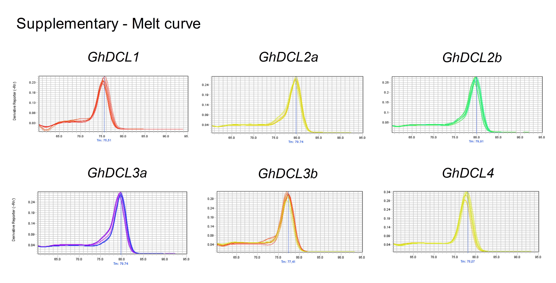

Figure S2: Expression pattern of G. hirsutum acc. FM DCL genes based on transcriptome sequencing data
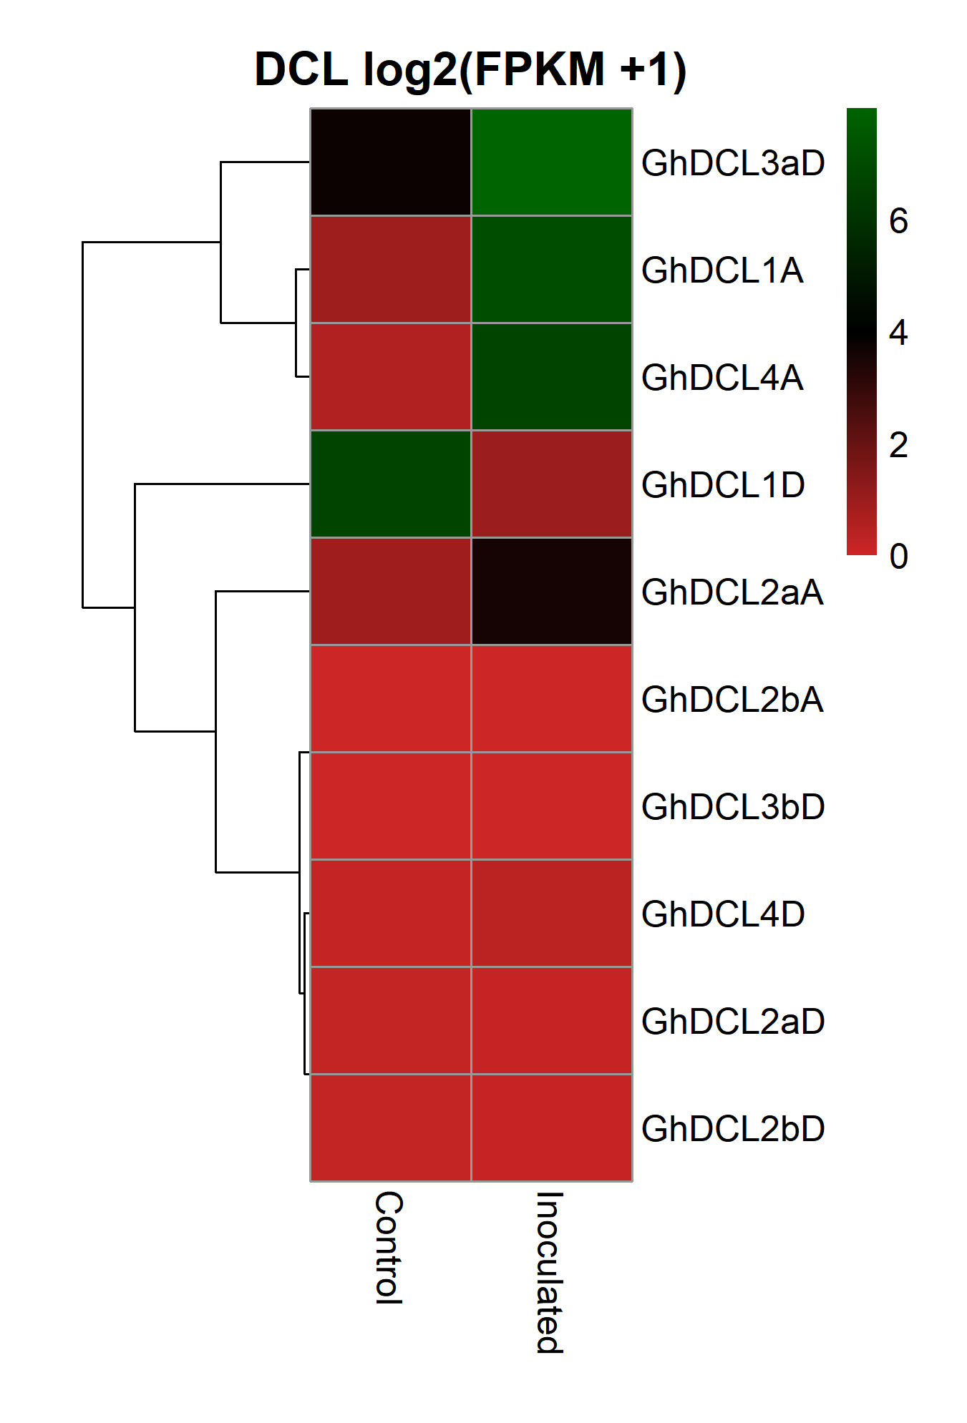
Expression pattern of the DCLs in uninfected (control) and 5 dpi CLRDV infected leaves were obtained as log of FPKM +1 values and calculated by Z-Score. A and D after DCL names represent the subgenome where the gene is found. For transcriptome analysis, plants were grown in greenhouse conditions and infected with CLRDV 60 days after germination as described in methods.

